REGALIS WORKSPACE
Maintenance & Housekeeping — Complete Feature Specification
Single-feature build document for the development team — checklist, schedules and housekeeper tracking
Module: Maintenance (Admin, Supervisor, Housekeeper)
Menu: Operations → Maintenance
Project Manager: Kausika
Based on: Regalis – Maintenance & Housekeeping Module, 25 September 2026
Document Version: 1.0 — September 2026

How To Use This Document
This document is self-contained. It describes ONE feature (Maintenance & Housekeeping) end to end: what it does, what it looks like, every field it needs, and the exact flows a developer should build. It can be handed to Claude on its own, together with the existing Regalis codebase.
- Section 1 explains the module in plain terms and what changes from the current Maintenance page.
- Section 2 lists roles and permissions: who can do what.
- Section 3 shows every screen with a design reference image, described field by field.
- Section 4 has the 4 flow charts: the overall module flow, add work, add housekeeper, and completion with verification.
- Section 5 gives the data fields, progress formulas and business rules.
- Section 6 is the build checklist from the functional document, in the order to build it.
- Section 7 lists open questions, and Section 8 is a summary for the developer.
NOTE: Build this inside the existing app. Reuse the current admin layout, sidebar, table component, form inputs, buttons and colour variables. The Maintenance menu item and the schedule list already exist; this document keeps that list as one tab and adds the checklist, housekeepers and reports tabs around it.
NOTE: The live UI design for every screen here is on the Regalis Maintenance design canvas. The images in Section 3 come from it; open the canvas to check exact spacing, colours and text.

1. What Is the Maintenance Module?
The Maintenance module gives the admin one checklist of all housekeeping and repair work, shows how much of it is done, and tracks which housekeeper did each task. Admins add work items and housekeepers, housekeepers mark their tasks done from their phone, and a supervisor verifies the work. Only verified work counts as complete.
It has four parts, shown as four tabs on a single Maintenance page:
Tab | What it holds | Who uses it
Checklist | Every work item with status, priority, assignee, due time and a progress bar showing % verified | Admin, Supervisor, Housekeeper (own tasks)
Schedules | The existing list of workspace blocks: schedule ID, staff, where, window and status | Admin, Supervisor
Housekeepers | Staff list with shift, assigned areas, today's work count, on-time rate and Active/Inactive | Admin
Reports | Work log per housekeeper, filters by date, area, status; daily and weekly export | Admin, Supervisor

1.1 What Changes From the Current Page
Today | After this build
Only a schedule list with a status dropdown | Four tabs; the schedule list stays as the Schedules tab, with search and more filters
No checklist of work items | A full checklist with work ID, area, category, priority, assignee, due time and status
No sense of how much is done | Summary cards and a progress bar: 18 of 25 verified = 72%
No housekeeper records | Housekeepers tab with shift, areas, today's count, on-time rate, Active/Inactive
No way for staff to update work | Housekeeper phone view: Start task, Mark done with a note and photo
No checking of finished work | Supervisor verify or send back for rework, with a reason
No overdue handling | Automatic Overdue status once the due time passes, with alerts
NOTE: A schedule and a work item are linked but not the same thing. A schedule blocks a workspace for a time window (and removes that slot from customer availability); a work item is the task a housekeeper must finish. When "Block this workspace" is ticked while adding work, the system creates both and keeps them in step.

2. Roles and Permissions
Three roles use this module. Enforce every rule on the server, not only by hiding buttons.
Action | Admin | Supervisor | Housekeeper
View full checklist | Yes | Yes | Own tasks only
Add / edit work | Yes | Yes | No
Delete work | Yes | No | No
Add / deactivate housekeeper | Yes | No | No
Assign or reassign work | Yes | Yes | No
Mark work as done | Yes | Yes | Yes
Verify / reject work | Yes | Yes | No
View reports | Yes | Yes | No
Create / edit schedules | Yes | Yes | No
NOTE: A housekeeper can never verify their own work. If a supervisor marks a task done themselves, another supervisor or the admin must verify it.

3. Screens — What It Should Look Like
Theme: warm cream background, gold/amber accent, white cards with soft rounded corners, a serif font for page titles and a clean sans-serif for body text. Colors: background #FBF6EC, card #FFFFFF, border #E6DAC2, gold accent #CC9A3D, gold-deep #A8761B, ink/text #241F19, muted grey #6E6559.
Status pill | Background | Text colour
Pending | #EEEAE3 | #4F4A42
In progress | #E4ECF7 | #255089
Done (waiting) | #F5EBD0 | #7A5D10
Verified | #E3F3EA | #15603C
Rework | #FBE7E5 | #93190F
Overdue | #FBE0CF | #8A4A0C

Priority chip | Background | Text colour
High | #FBE7E5 | #93190F
Medium | #FBE0CF | #8A4A0C
Low | #EDEAE2 | #4F4A42

3.1 Maintenance — Checklist Tab (main screen)
This is the default tab when Maintenance opens. It answers three questions at a glance: what work is there today, how much is done, and who is behind.
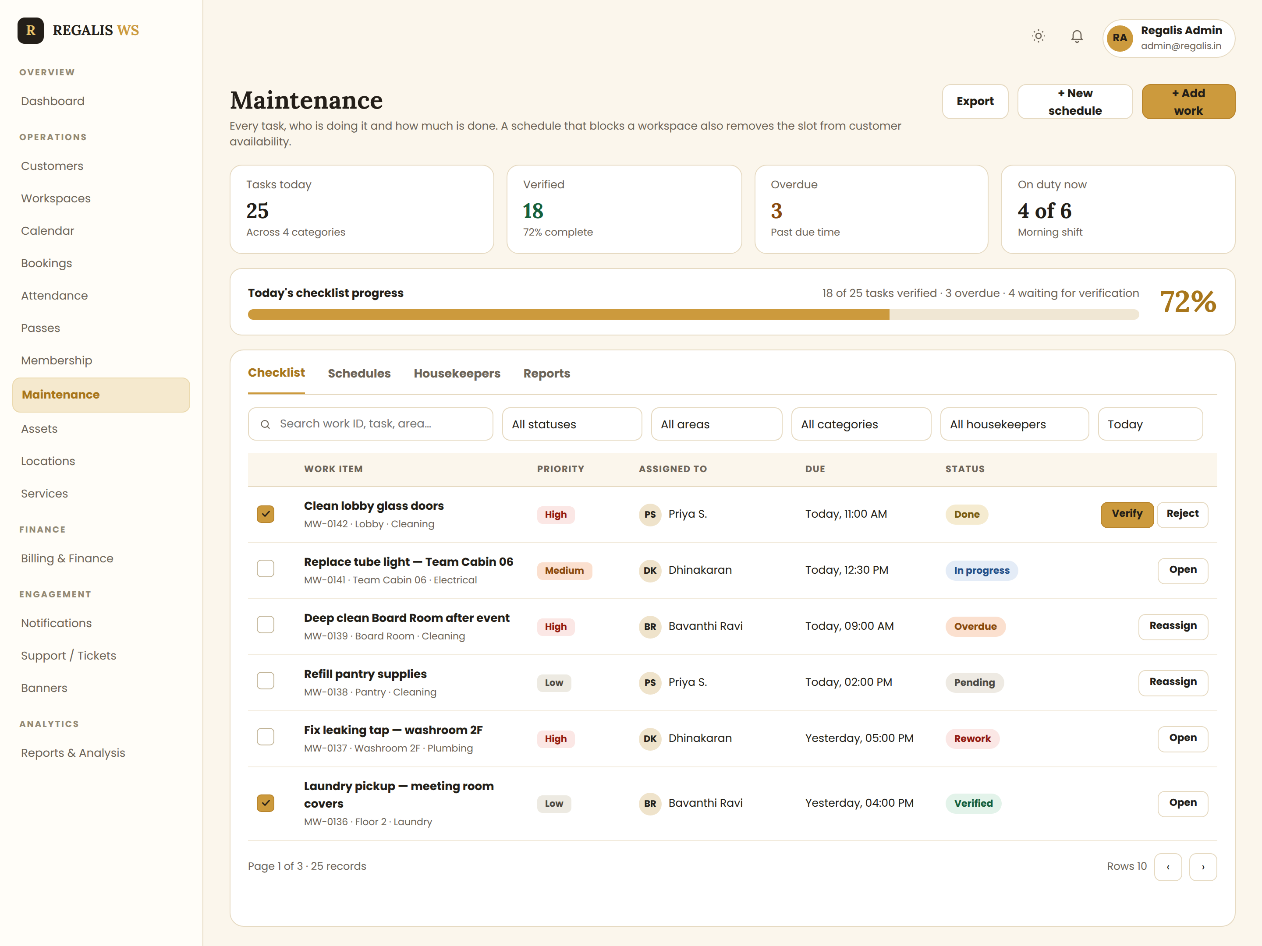
Reference: checklist tab with summary cards, progress bar, filters and work items
- Summary cards: Tasks today · Verified (with % complete) · Overdue (amber) · On duty now (staff on the current shift).
- Progress bar: "Today's checklist progress" with the sub-line "18 of 25 tasks verified · 3 overdue · 4 waiting for verification" and the percentage in large gold type. Only verified tasks fill the bar.
- Filters: search (work ID, task, area), status, area, category, housekeeper and date.
- Each row shows: a tick box (ticked only when verified), the task title, then work ID · area · category underneath, priority chip, assignee with avatar, due time, status pill, and the action for that status.
- Row actions by status: Pending and Overdue → Reassign; In progress and Rework → Open; Done → Verify (gold) and Reject; Verified → Open.
- Buttons at top right: Export · + New schedule · + Add work (gold).
- Overdue rows show the due time in amber. Empty state: "No work added for today — add the first task."
- Housekeeper view of this tab: the same list filtered to their own tasks, with no Verify or Reassign buttons.

3.2 Maintenance — Schedules Tab (your existing page, rebuilt)
The current Maintenance page becomes this tab. The columns stay exactly as they are today; search, filters and row actions are added.
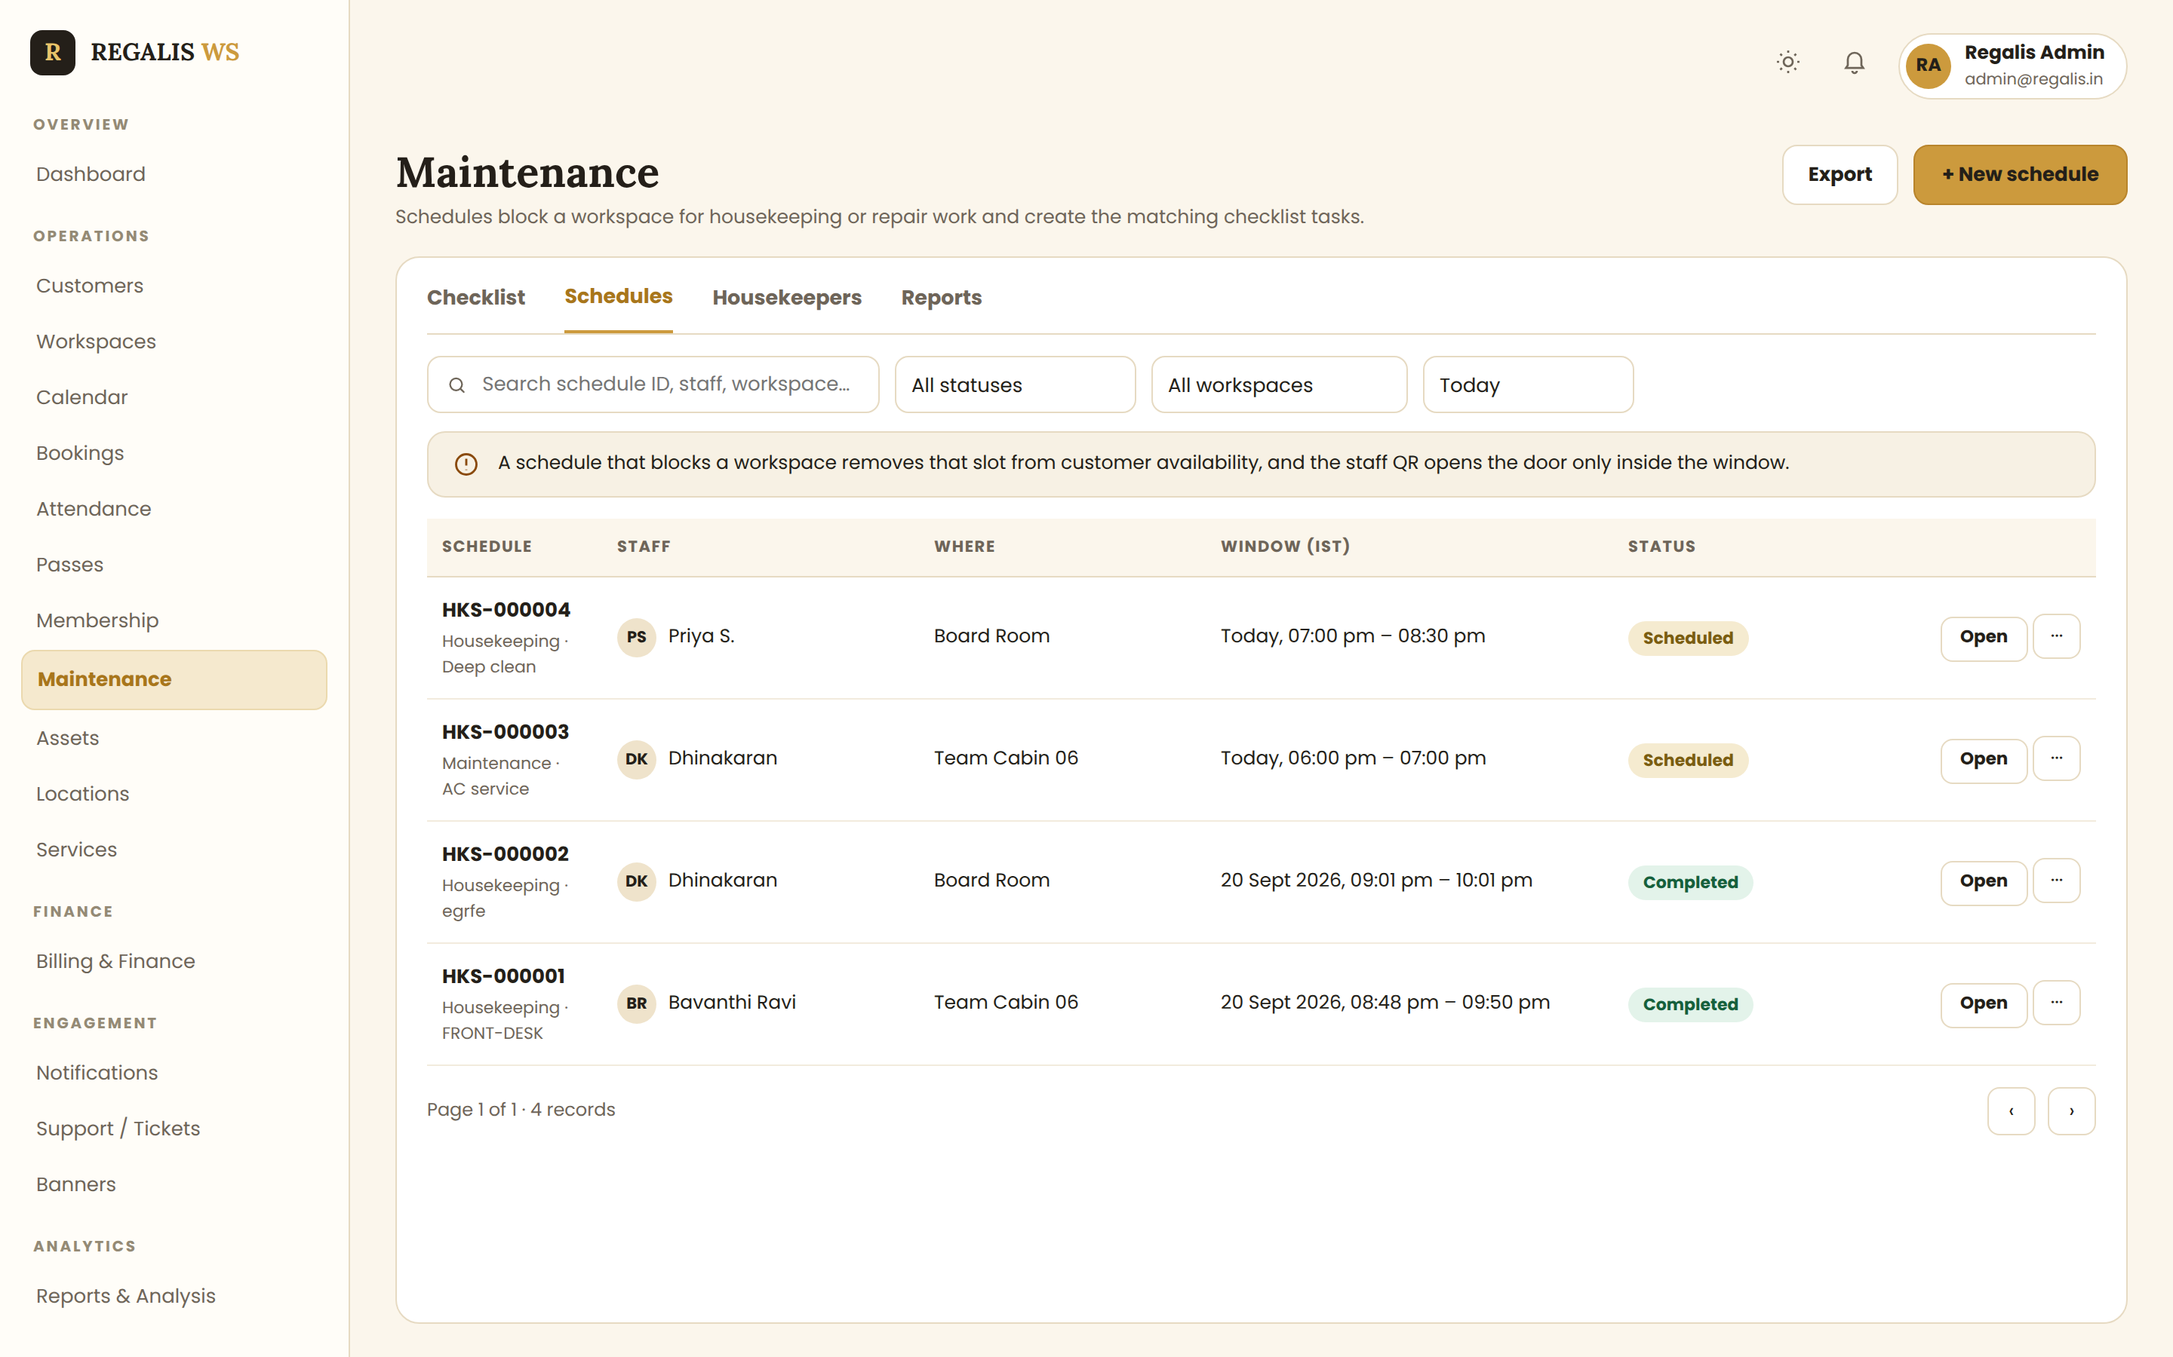
Reference: schedules tab — schedule ID, staff, where, window and status
- Columns: Schedule (ID + type · reference), Staff (with avatar), Where, Window (IST), Status, Open + ⋯.
- Statuses: Scheduled, In progress, Completed, Cancelled.
- Filters: search, status, workspace and date.
- The note bar stays: a schedule that blocks a workspace removes that slot from customer availability, and the staff QR opens the door only inside the window.
- + New schedule opens the existing schedule form; when it is for housekeeping, it also creates the matching checklist task.

3.3 Maintenance — Housekeepers Tab
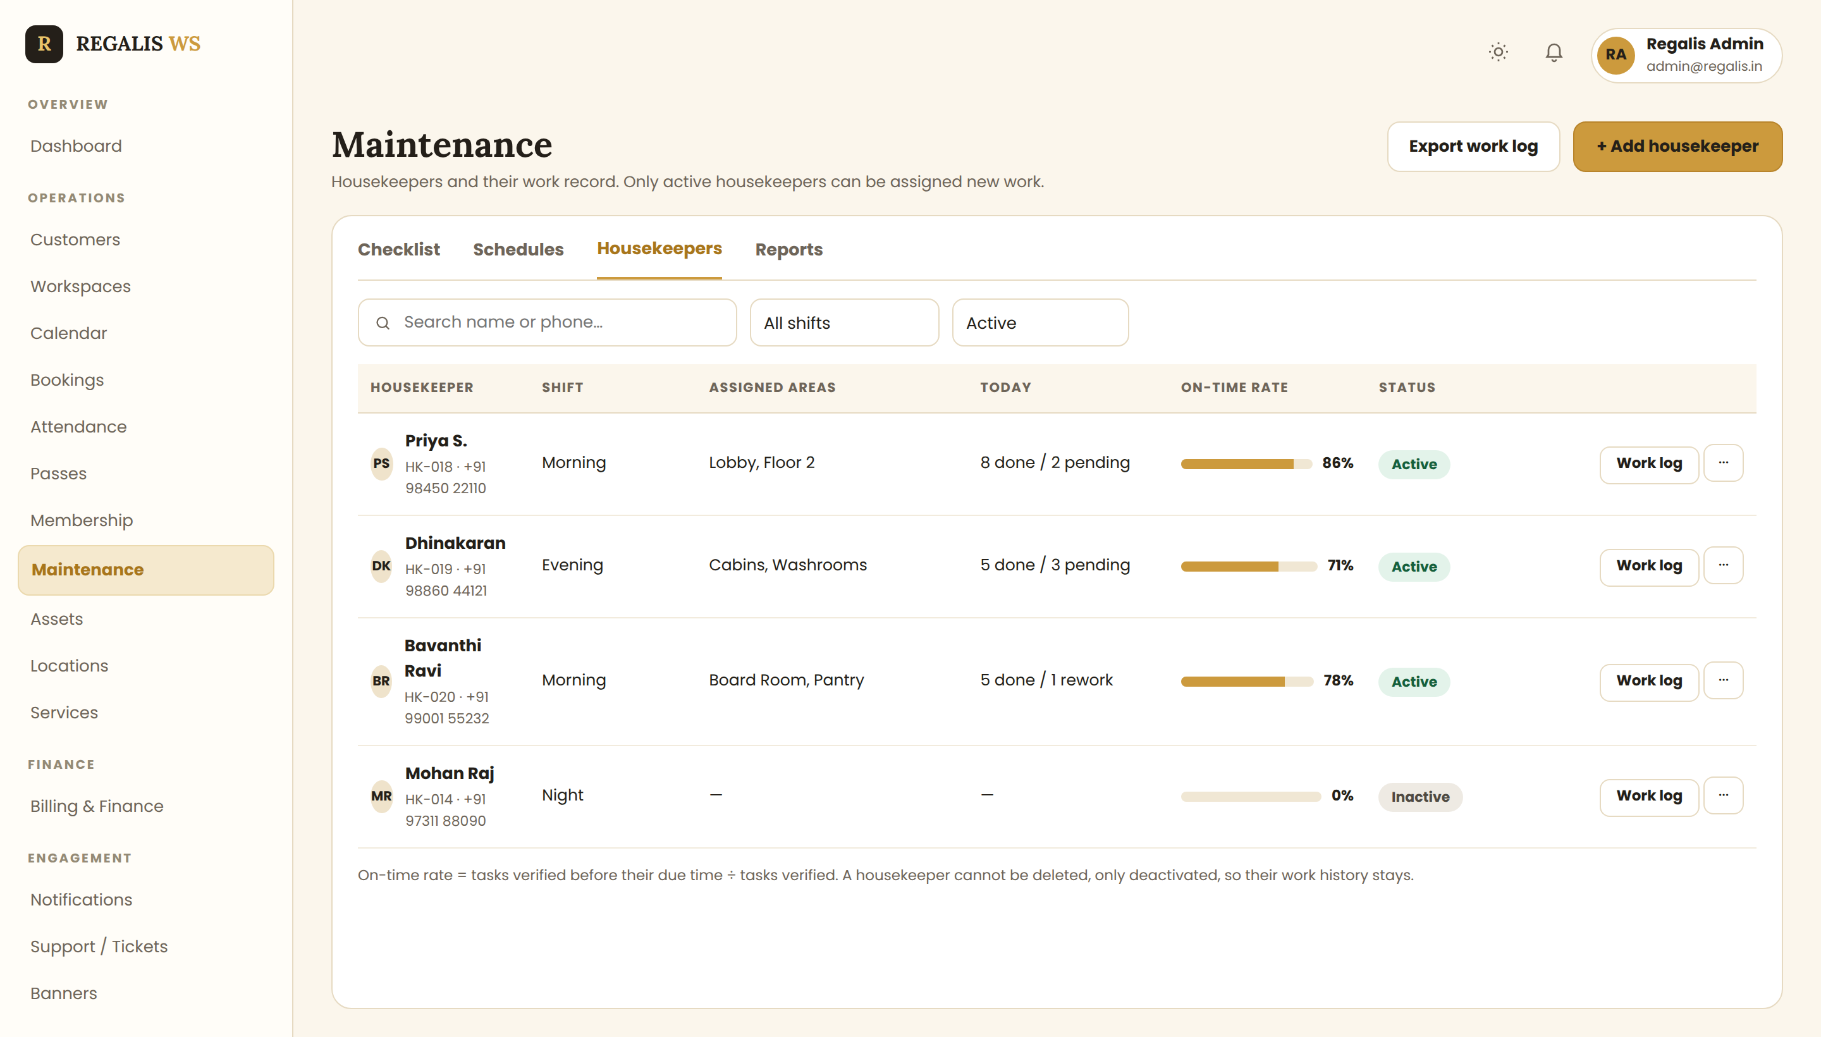
Reference: housekeepers tab with shift, areas, today's work and on-time rate
- Columns: Housekeeper (avatar, name, ID · phone), Shift, Assigned areas, Today (done / pending), On-time rate (bar + %), Status, Work log + ⋯.
- Filters: search by name or phone, shift, and Active / Inactive (default Active).
- Work log opens that person's history: tasks assigned, completed, pending, overdue, rework count and average time per task.
- ⋯ menu: Edit, Reassign open tasks, Deactivate. A housekeeper is never deleted, only deactivated, so the work history stays.
- On-time rate = tasks verified before their due time ÷ tasks verified.

3.4 Add New Work
Opened by the gold "+ Add work" button. Saving creates the work item, gives it an ID like MW-0142, and notifies the housekeeper.
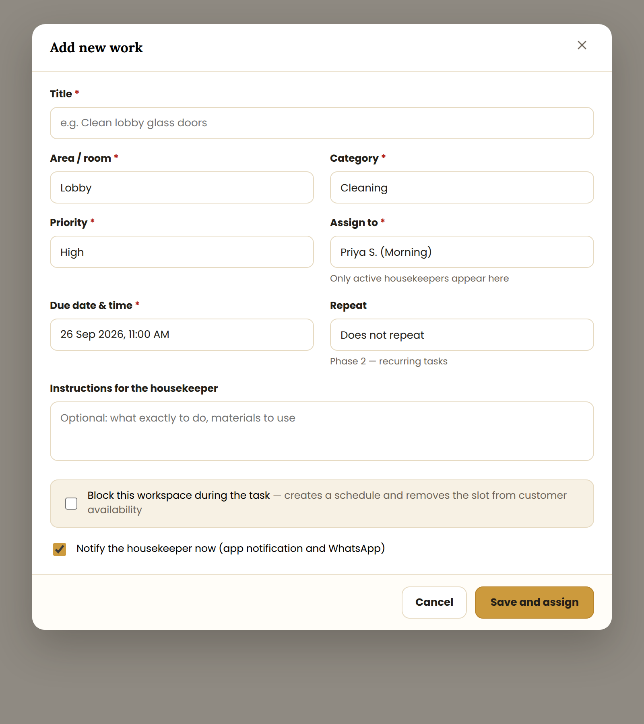
Reference: Add new work form
- Required: Title, Area/room, Category, Priority, Assign to, Due date & time.
- Assign to lists only active housekeepers, showing their shift beside the name.
- Instructions for the housekeeper is an optional free-text box shown to them in the app.
- Block this workspace during the task: creates a linked schedule and removes that slot from customer availability.
- Notify the housekeeper now: on by default; sends an app notification and a WhatsApp message.
- Repeat (Does not repeat / Every day / Every week) is Phase 2 — show it disabled or hide it for now.

3.5 Add Housekeeper, and Verify Work
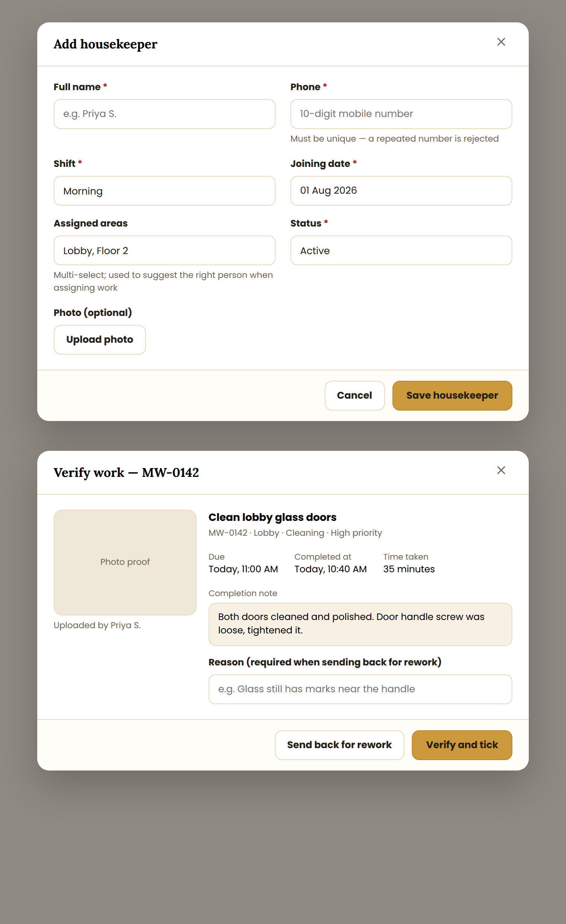
Reference: Add housekeeper form (top) and the supervisor's verify screen (bottom)
- Add housekeeper: Full name, Phone (unique), Shift, Joining date, Assigned areas, Status, optional photo. A repeated phone number is rejected with "This phone number is already registered".
- Verify work: shows the photo proof, the completion note, due time, completed time and time taken.
- Verify and tick sets the status to Verified, adds the supervisor's name and moves the progress bar.
- Send back for rework requires a reason, sets the status to Rework, and notifies the housekeeper.

3.6 Housekeeper App — My Tasks
Housekeepers work from a phone. This view is deliberately simple: what to do next, and two buttons.
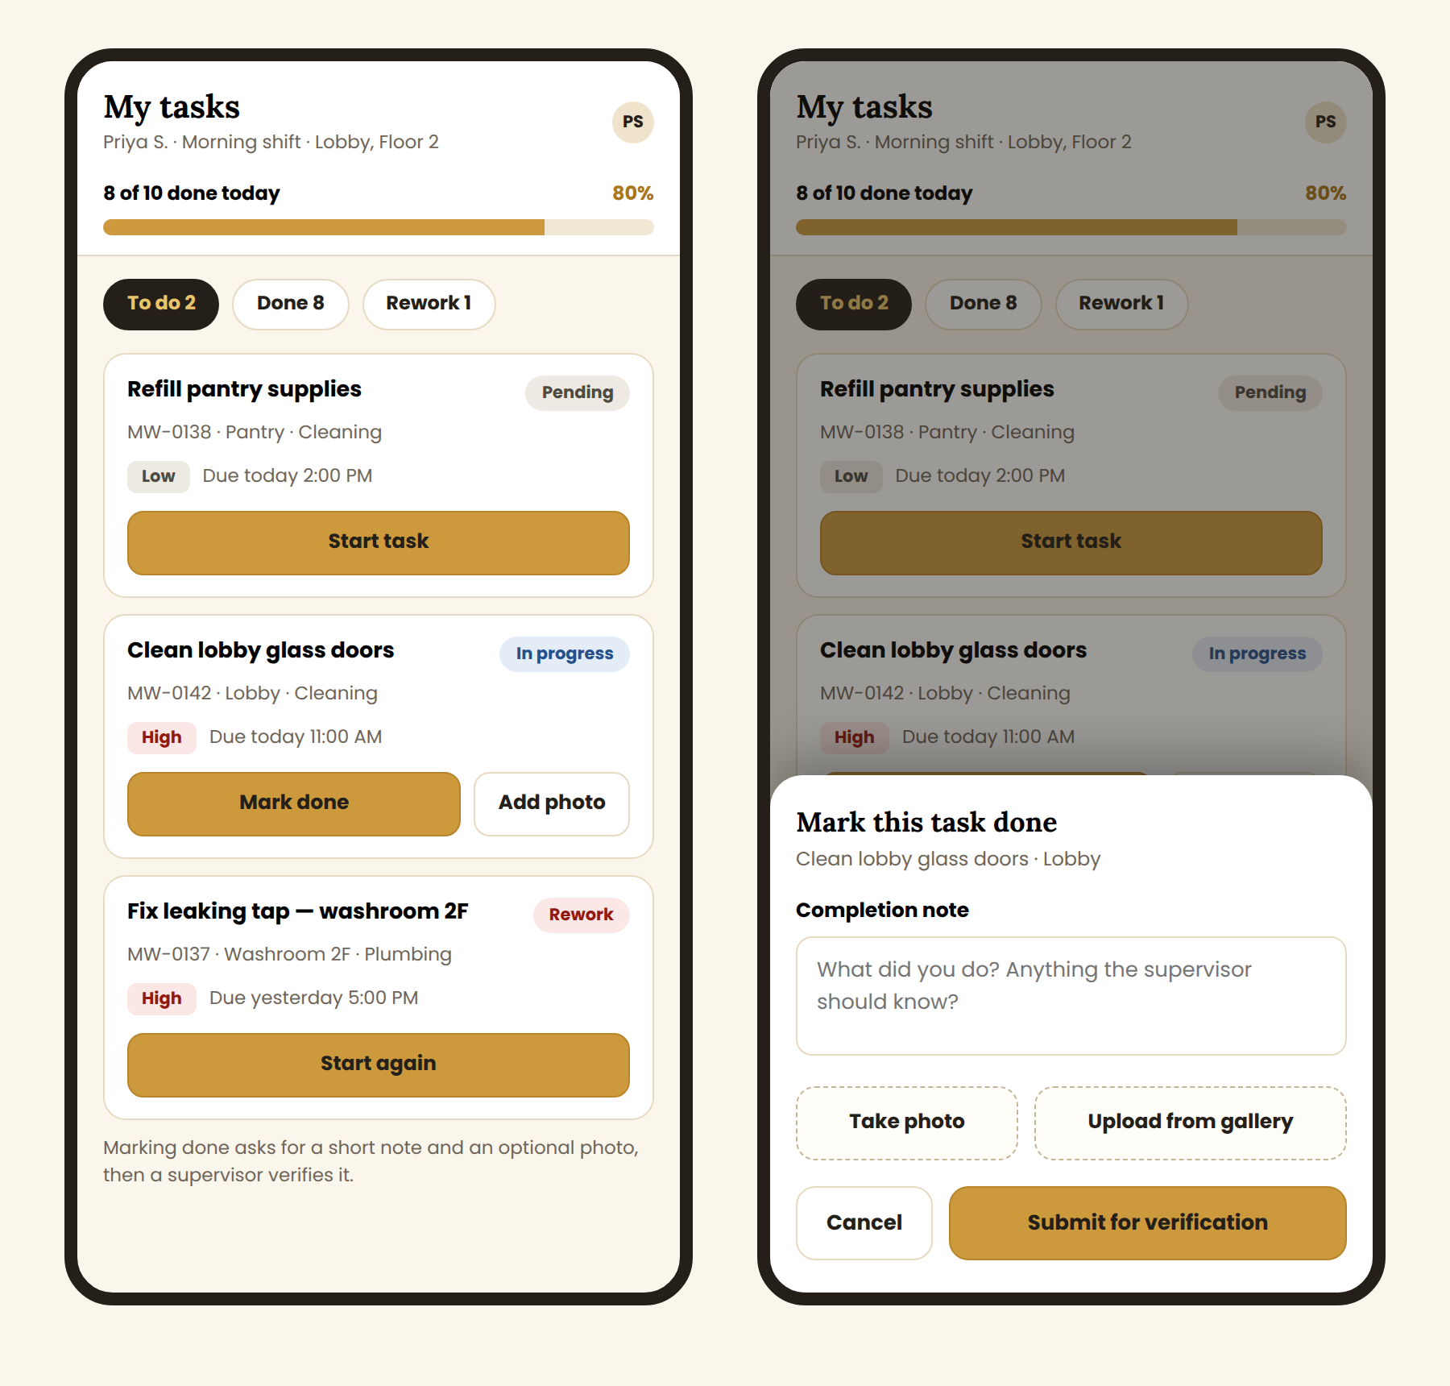
Reference: housekeeper "My tasks" view and the Mark done sheet
- Header shows the housekeeper's name, shift and areas, with their own progress for the day (8 of 10 done = 80%).
- Tabs: To do · Done · Rework, each with a count.
- Each task card shows the title, work ID · area · category, priority chip, due time and status.
- Start task sets In progress and records the start time. Mark done opens the sheet below.
- Mark done sheet: completion note, Take photo or Upload from gallery, then Submit for verification.
- Touch targets are at least 44 px high, since this is used on the move.

4. Complete Flow Charts

4.1 Overall Module Flow
Every task starts with an admin adding work, passes through a housekeeper, and ends as a verified tick on the checklist.
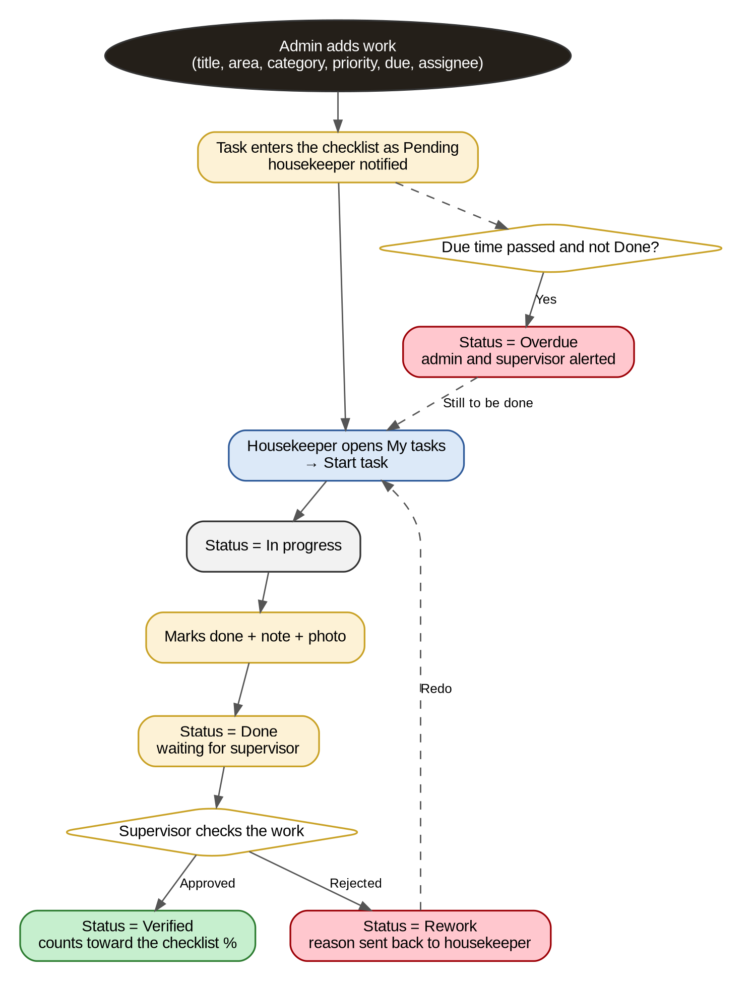
Figure 1 — From adding work to a verified tick, including overdue and rework

4.2 Add New Work
A task is saved only when the required fields pass validation; it enters the checklist as Pending.
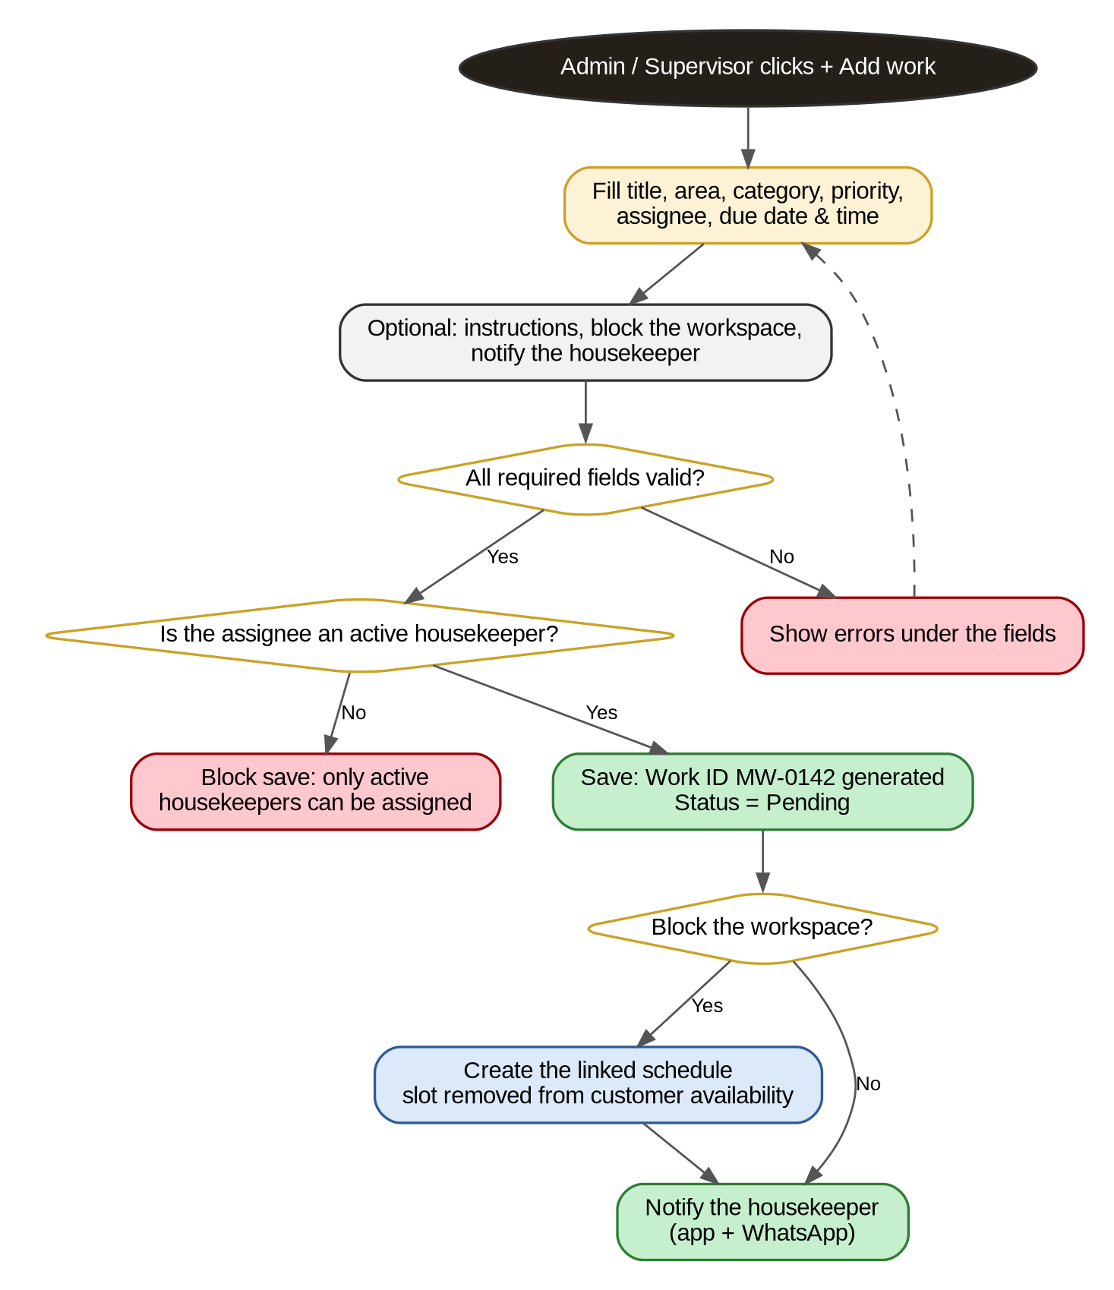
Figure 2 — Adding and assigning a work item

4.3 Add New Housekeeper
The phone number check stops the same person being added twice.
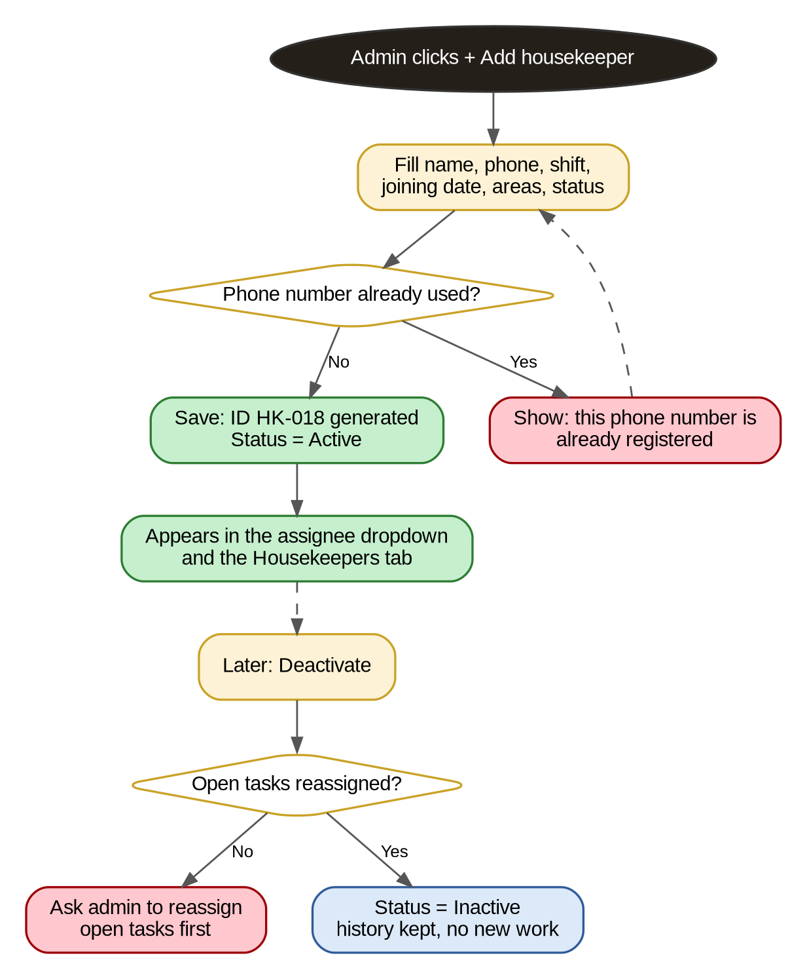
Figure 3 — Adding a housekeeper, and deactivating one later

4.4 Status Lifecycle
A task moves forward only through these states, plus Overdue when the due time passes unfinished.
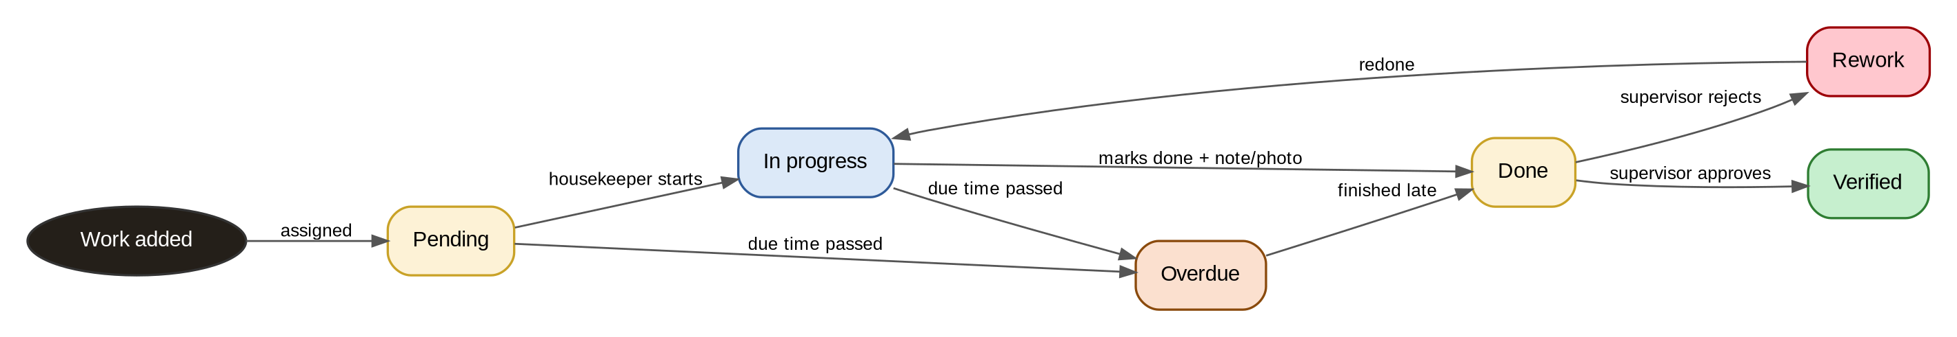
Figure 4 — Work item status lifecycle
NOTE: Only verified tasks count toward the checklist percentage and toward a housekeeper's completed count. A task marked done by a housekeeper does not move the progress bar until a supervisor approves it.

5. Data Fields, Progress and Business Rules

5.1 Work Item
Field | Type | Required | Example
Work ID | Auto number | Yes | MW-0142
Title | Text | Yes | Clean lobby glass doors
Area / room | Dropdown | Yes | Lobby, Team Cabin 06
Category | Dropdown | Yes | Cleaning, Plumbing, Electrical, Laundry
Priority | Low / Medium / High | Yes | High
Assigned to | Housekeeper | Yes | Priya S.
Due date and time | Date-time | Yes | 26 Sep 2026, 11:00 AM
Status | Pending / In progress / Done / Verified / Rework / Overdue | Yes | Pending
Instructions | Text | No | Use the glass cleaner, not the floor one
Completion note | Text | No | Replaced bulb
Photo proof | Image | No | photo.jpg
Started at / Completed at | Date-time | Auto | 26 Sep, 10:05 AM / 10:40 AM
Verified by / Verified at | Supervisor, date-time | Auto | Ravi K., 26 Sep 11:02 AM
Rework reason | Text | Auto | Glass still has marks near the handle
Linked schedule | Schedule ID | No | HKS-000004

5.2 Housekeeper
Field | Type | Required | Example
Housekeeper ID | Auto number | Yes | HK-018
Full name | Text | Yes | Priya S.
Phone | Text (unique) | Yes | 98XXXXXX10
Shift | Morning / Evening / Night | Yes | Morning
Assigned areas | Multi-select | No | Lobby, Floor 2
Joining date | Date | Yes | 01 Aug 2026
Status | Active / Inactive | Yes | Active

5.3 How Progress Is Calculated
- Checklist progress % = verified tasks ÷ total tasks × 100. Example: 18 ÷ 25 = 72%.
- Housekeeper completion rate = tasks verified ÷ tasks assigned, per person.
- On-time rate = tasks verified before their due time ÷ tasks verified.
- Overdue count = tasks past their due time that are not Done, Verified or Rework.
- All four are calculated on the server for the selected date range, and default to today.

5.4 Business Rules
- Work IDs (MW-) and housekeeper IDs (HK-) are auto-generated and never reused.
- Only active housekeepers appear in the assignee dropdown; deactivating a person requires their open tasks to be reassigned first.
- A phone number can belong to only one housekeeper, active or inactive.
- A housekeeper can only see, start and complete their own tasks.
- Marking done requires a completion note; the photo is optional but recommended for Cleaning tasks.
- A rejected task returns to In progress for the same housekeeper, with the rework reason shown to them, and its rework count goes up by one.
- A background job sets Overdue every 5 minutes for tasks past their due time that are not finished, and alerts the admin and supervisor.
- Deleting work is admin-only and only allowed while the task is Pending; anything further along is cancelled with a reason instead.
- Every change (created, assigned, started, done, verified, rejected, overdue, deleted) is written to an audit log with who and when.
- Notifications: to the housekeeper on assignment and rework; to the supervisor when a task is waiting for verification; to admin and supervisor on overdue.

5.5 Validation Messages
Field | Rule | Message
Title | Required | Enter a title for the work.
Area / Category / Priority | Required | Select an area, a category and a priority.
Assign to | Required, active only | Select an active housekeeper.
Due date and time | Required, not in the past | Due time cannot be in the past.
Completion note | Required when marking done | Add a short note about what you did.
Rework reason | Required when rejecting | Tell the housekeeper what needs redoing.
Phone | Unique, 10 digits | This phone number is already registered.

6. Build Checklist (in order)
This is the checklist from the functional document, arranged in the order it should be built. Tick each item as it is finished; the list doubles as the build tracker.

6.1 Housekeeper Management
- Add housekeeper form with validation
- Duplicate phone number check
- Housekeeper list with search and Active / Inactive filter
- Edit and deactivate housekeeper (with reassign check)

6.2 Work Management
- Add work form (title, area, category, priority, due date, assignee)
- Assign and reassign work to active housekeepers
- Edit and delete work (admin only)
- Notification to the housekeeper on new assignment
- Optional linked schedule when the workspace must be blocked

6.3 Checklist and Tracking
- Maintenance checklist page with status badges and priority chips
- Progress bar showing % verified, with summary cards
- Housekeeper "My tasks" view with Start and Mark done
- Completion note and photo upload
- Supervisor verify / reject with reason
- Automatic Overdue status after the due time

6.4 Schedules Tab
- Existing schedule list moved into the Schedules tab
- Search, status, workspace and date filters
- Schedule and work item kept in step when linked

6.5 Reports
- Housekeeper work log (completed, pending, overdue, rework, average time)
- Filters by date, area, housekeeper and status
- Daily and weekly summary export

6.6 Access and Testing
- Role-based permissions (Admin, Supervisor, Housekeeper) enforced on the server
- Testing of every flow in Section 4

6.7 Future Enhancements (do not build now)
- Recurring tasks generated automatically (daily, weekly)
- QR code per room so housekeepers scan to open and close a task
- Performance dashboard ranking housekeepers by on-time rate
- SMS or WhatsApp alerts for overdue tasks

7. Open Items — Confirm Before / While Building
# | Assumption Made Here | Needs Confirmation
1 | Only verified tasks count toward the progress % | Confirm with the Project Manager; the alternative is counting Done as well
2 | The Supervisor role exists separately from Admin | Whether Regalis has supervisors today, or the admin verifies everything
3 | Housekeepers use the same app with a restricted view | Whether they get app logins at all, or the supervisor updates on their behalf
4 | Categories: Cleaning, Plumbing, Electrical, Laundry, Other | Final category list
5 | Overdue is set 5 minutes after the due time by a background job | Grace period, if any
6 | Photo proof is optional | Whether photos should be compulsory for some categories
7 | A housekeeper is deactivated, never deleted | Confirmed practice for staff records

8. Summary For The Developer
If you only read one paragraph of this document, read this one:
NOTE: Turn the Maintenance page into one page with four tabs in the Regalis cream-and-gold theme: Checklist (every work item with priority, assignee, due time, status and a progress bar showing % verified), Schedules (the existing workspace-blocking list, kept as it is with better filters), Housekeepers (staff with shift, areas, today's count and on-time rate) and Reports. Admins add work and housekeepers; housekeepers start and complete their own tasks from a phone with a note and photo; supervisors verify or send back for rework; the system marks anything past its due time as Overdue. Only verified tasks move the progress bar. IDs (MW-, HK-), statuses and all percentages are calculated on the server.

